A REPORT

ON

TITLE OF THE INTERNSHIP/PROJECT

Submitted by,

Mr. XYZ - 20211CSE0123

Under the guidance of,
Dr./Mr./Ms. IJKL

in partial fulfillment for the award of the degree of
BACHELOR OF TECHNOLOGY

IN

COMPUTER SCIENCE AND ENGINEERING

At



PRESIDENCY UNIVERSITY
BENGALURU
MAY 2025

PRESIDENCY UNIVERSITY

PRESIDENCY SCHOOL OF COMPUTER SCIENCE AND ENGINEERING

CERTIFICATE

This is to certify that the Internship/Project report “TITLE OF THE INTERNSHIP/PROJECT” being submitted by “STUDENT NAME” bearing roll number “STUDENT ROLL NUMBER” in partial fulfillment of the requirement for the award of the degree of Bachelor of Technology in Computer Science and Engineering is a bonafide work carried out under my supervision.

Dr/Mr/Ms. <SUPERVISOR NAME>  DESIGNATION  PSCS / PSIS  Presidency University | Dr. <HoD Name>  DESIGNATION & HoD  PSCS  Presidency University

Dr. MYDHILI NAIR  Associate Dean  PSCS  Presidency University | Dr. SAMEERUDDIN KHAN  Pro-Vice Chancellor - Engineering  Dean –PSCS / PSIS  Presidency University

PRESIDENCY UNIVERSITY

PRESIDENCY SCHOOL OF COMPUTER SCIENCE AND ENGINEERING

DECLARATION

I hereby declare that the work, which is being presented in the report entitled “TITLE OF THE INTERNSHIP/PROJECT” in partial fulfillment for the award of Degree of Bachelor of Technology in Computer Science and Engineering, is a record of my own investigations carried under the guidance of SUPERVISOR NAME, DESIGNATION, Prsidency School of Computer Science and Engineering, Presidency University, Bengaluru.

I have not submitted the matter presented in this report anywhere for the award of any other Degree.

Name, Roll No and Signature of the Student

INTERNSHIP COMPLETION CERTIFICATE

- The certificate issued from an organization must have the duration of the Internship, i.e.start and end date, project title and a technology on which work is carried out.

ABSTRACT

ACKNOWLEDGEMENTS

First of all, we indebted to the GOD ALMIGHTY for giving me an opportunity to excel in our efforts to complete this project on time.
We express our sincere thanks to our respected dean Dr. Md. Sameeruddin Khan, Pro-VC - Engineering and Dean, Presiency School of Computer Science and Engineering & Presiency School of Information Science, Presidency University for getting us permission to undergo the project.
We express our heartfelt gratitude to our beloved Associate Dean Dr. Mydhili Nair, Presidency School of Computer Science and Engineering, Presidency University, and Dr. “NAME OF THE HOD”, Head of the Department, Presidency School of Computer Science and Engineering, Presidency University, for rendering timely help in completing this project successfully.
We are greatly indebted to our guide Dr./Mr.Ms. Name, Designation and Reviewer Dr./Mr.Ms. Name, Designation, Presdiency School of Computer Science and Engineering, Presidency University for his/her inspirational guidance, and valuable suggestions and for providing us a chance to express our technical capabilities in every respect for the completion of the internship work.
We would like to convey our gratitude and heartfelt thanks to the PIP4001 Internship/University Project Coordinator Mr. Md Ziaur Rahman and Dr. Sampath A K, department Project Coordinators “NAME” and Git hub coordinator Mr. Muthuraj.
We thank our family and friends for the strong support and inspiration they have provided us in bringing out this project.

Name of the Student (1)
Name of the Student (2)
Name of the Student (3)
Name of the Student (4)
LIST OF TABLES

Sl. No. | Table Name | Table Caption | Page No.
1 | Table 1.1 | Software modules versus Reusable components | 5

LIST OF FIGURES

Sl. No. | Figure Name | Caption | Page No.
1 | Figure 1.1 | Software modules versus Reusable components | 5

TABLE OF CONTENTS

CHAPTER NO. | TITLE | PAGE NO.
 | ABSTRACT ACKNOWLEDGMENT  … | I  ii  …
1. | INTRODUCTION | 1
 | 1.1 GENERAL | 1
 | 1.2 . . . . . . . . . . . . | 2
 | 1.2.1 General | 5
 | 1.2.2.1 General | 8
 | 1.2.2.2 . . . . . . . . | 10
 | 1.2.2 | 12
 | 1.3 . . .. . . . . . .. . . . . . . | 13
 | 1.4 . . . . . . . . . . . . . . . . | 15
2. | LITERATURE REVIEW | 16
 | 2.1 GENERAL | 17
 | 2.2 . . . . .. | 19
 | 2.2. | 20

Chapter 1
INTRODUCTION

  - Sub topic-1
    - Sub topic-1 of Sub topic-1
Include the content here with font family Times New Roman. Chapter Name font size should be 16. Sub topic font size should be 14. Further sub topics & Body text font size should be 12. Line spacing 1.5.
1.2 Sub topic-2
1.3 Sub topic-3

Note: The students can prepare the report based on the work carried out during their Internship in an organization. If it is folllowed in the given template it will be of a high standard.

Chapter 2
LITERATURE SURVEY

Chapter 3
RESEARCH GAPS OF EXISTING METHODS

Chapter 4
PROPOSED MOTHODOLOGY

Chapter 5
OBJECTIVES

Chapter 6
SYSTEM DESIGN & IMPLEMENTATION

Chapter-7
TIMELINE FOR EXECUTION OF PROJECT
(GANTT CHART)
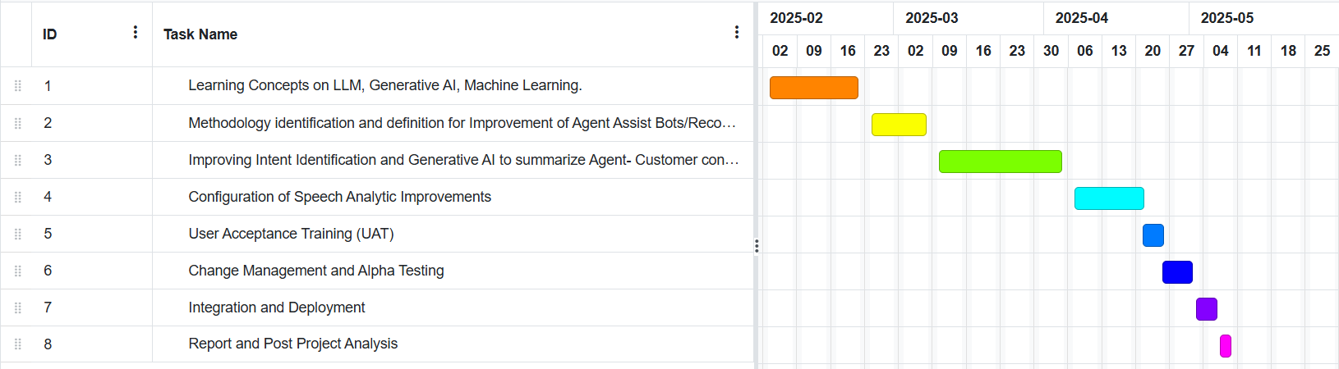
Chapter 8
OUTCOMES

Chapter 9
RESULTS AND DISCUSSIONS

Chapter 10
CONCLUSION

REFERENCES

APPENDIX-A
PSUEDOCODE

APPENDIX-B
SCREENSHOTS

APPENDIX-C
ENCLOSURES

1. Journal publication/Conference Paper Presented Certificates (if any).
2. Include certificate(s) of any Achievement/Award won in any project-related event.
3. Similarity Index / Plagiarism Check report clearly showing the Percentage (%). No need for a page-wise explanation.
4. Details of mapping the project with the Sustainable Development Goals (SDGs).

SUSTAINABLE DEVELOPMENT GOALS

